79919199

Base URL:

Agreement URL: https://innovareacademics.in/journals.php

Log onto the website using Agreement URL and Search source name in the web site to find relevant web site.

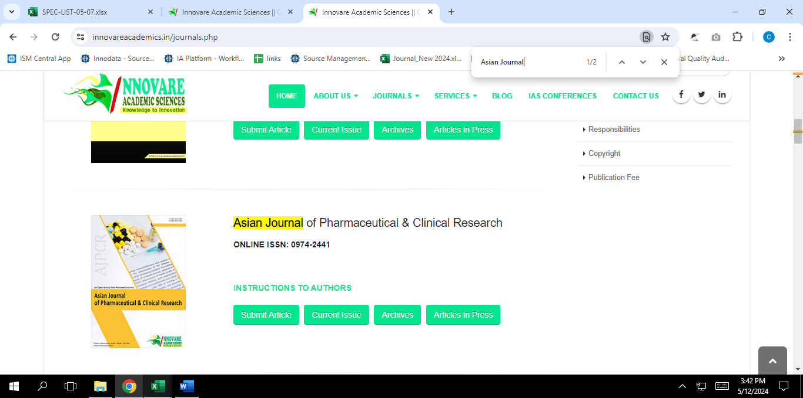

Log in to the relevant website

click the archive, current issue and archive listed the drop down.

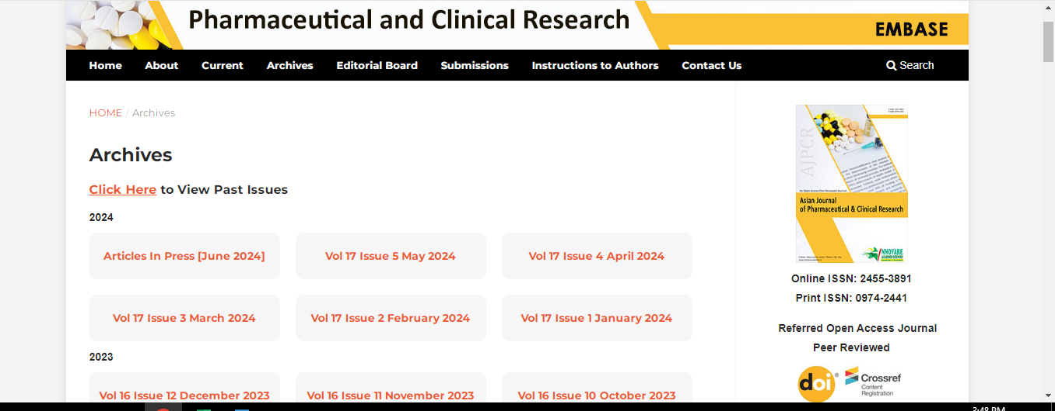



Click the archive and select issue to process by year, month volume & issue number.

for this snip current issue is 2020 -> 2024 -> January -> volume 90 -issue 1



After selecting volume issue all required articles will be listed here.



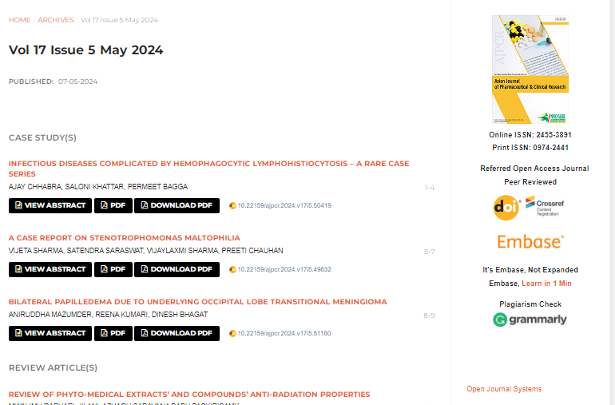

Click the article name to open the article info page to download the PDF.

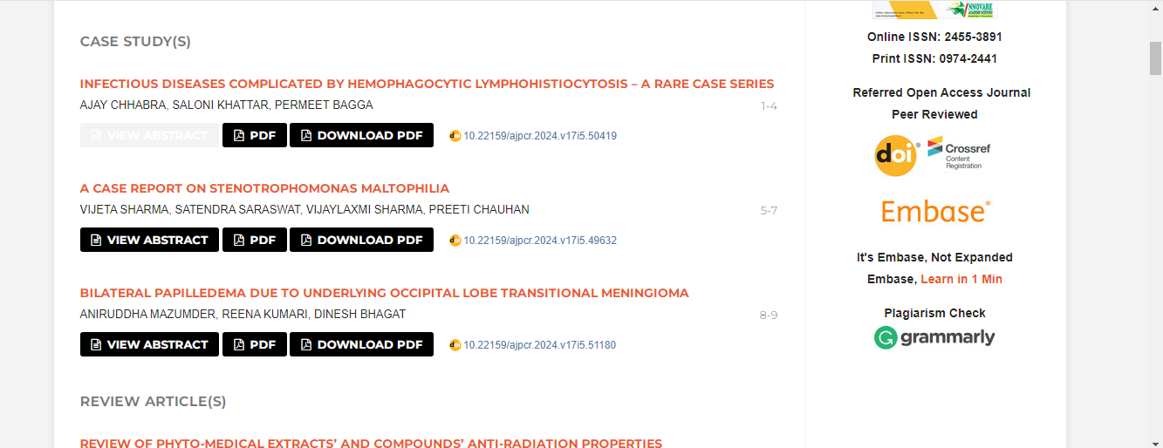



Apply following step to download the PDF.

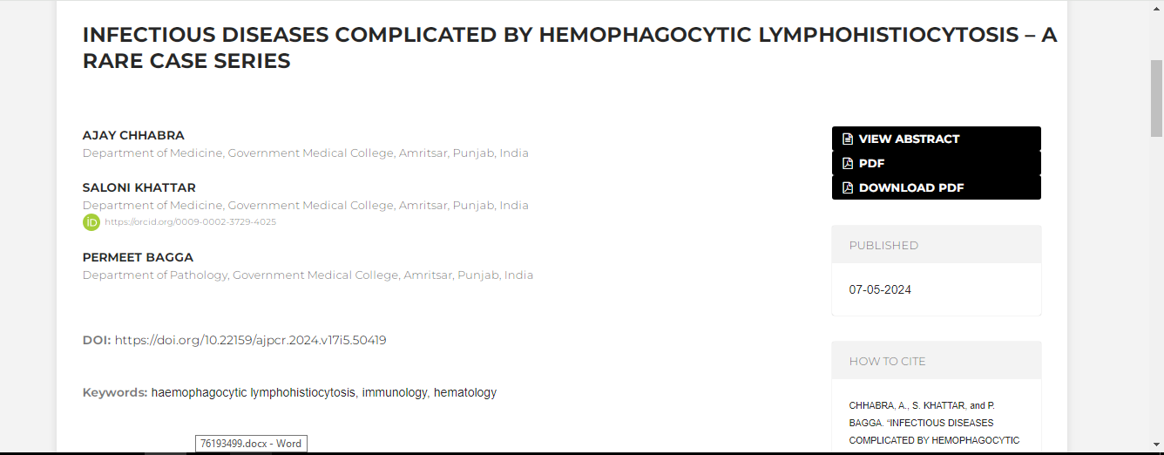

Click the download pdf to pdf download.



Meta data can be captured as below.

* Month, Date, Year
* Volume and issue

Volume issue

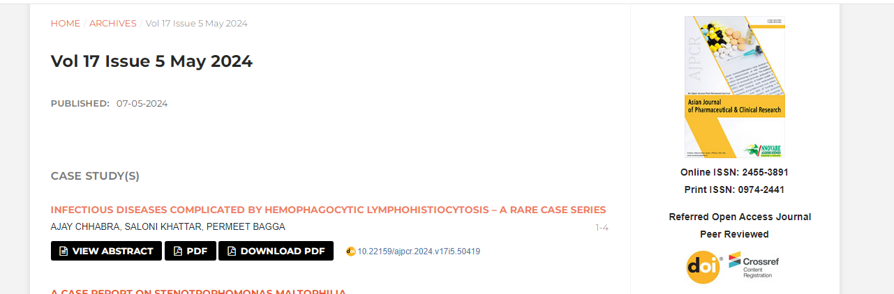



Month & Year

* Doi

